# Results from Lab 2

Wrong declarations for int, float, char.

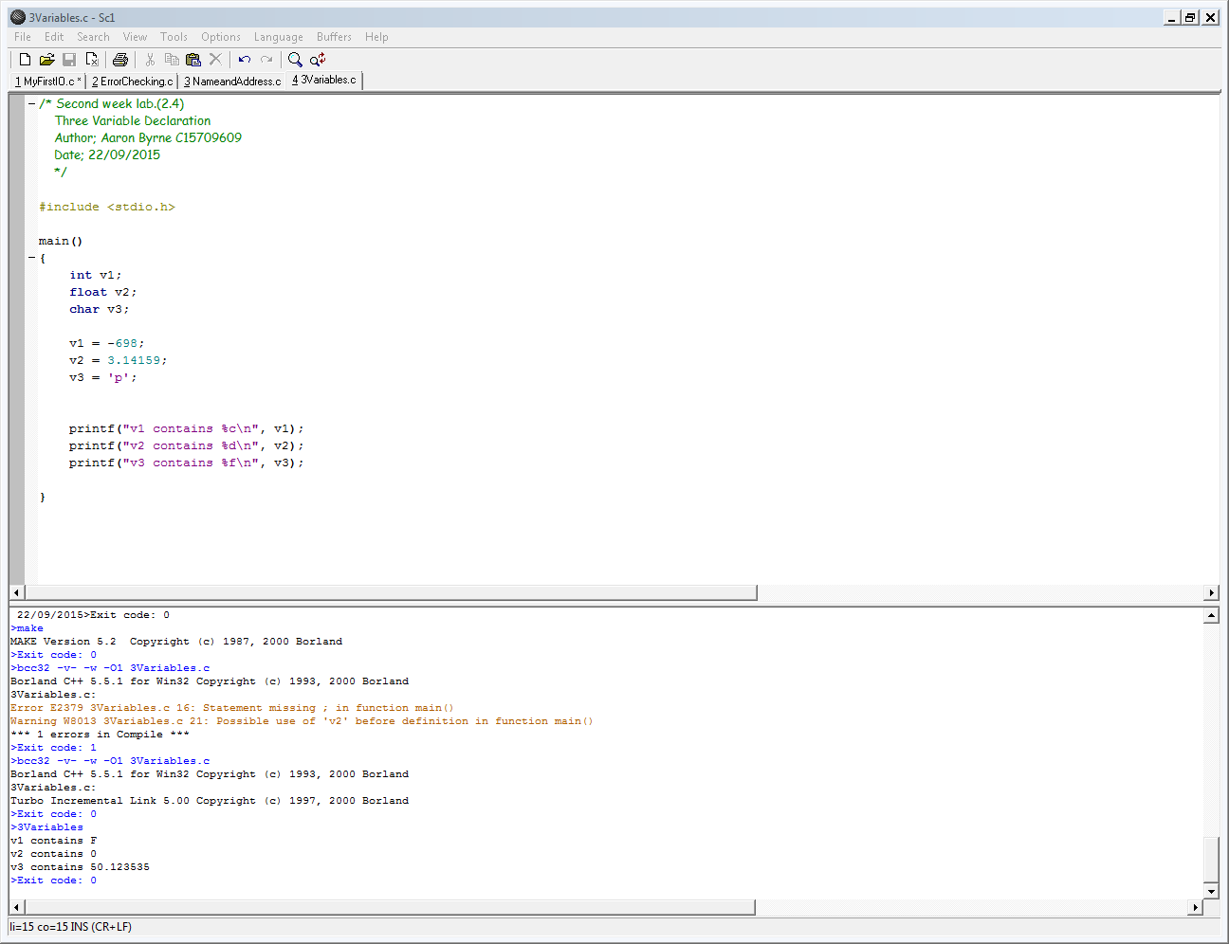

Using %d in char.

